**Sally’s Garden**

**INTRODUCTION**

A gardening program that asks user for item, dimensions of area, prints out area and then asks user if they want to order anything else. Client states that the pricing of fake grass is incorrect, the area doesn’t seem to be large enough when calculated and the program closes when they want to continue.

**INVESTIGATION OF THE PROBLEM**

The initial test (Figure 1) shows there is a problem with the calculation of garden area, price and is there another customer to serve functions.  
  
**PLANNING**  
I am going to edit the required lines of code in order to implement a solution. By follow the half step method I can work on the issues that I know are causing the issue. I will be following the six steps for each issue so I can methodically resolve the issues.

**RESOURCES**  
Eclipse Java

Microsoft Word  
Time

Knowledge  
  
**IMPLEMENT A SOLUTION**

The price of fake grass is incorrect on line 52 and should be changed from 12.3 to 11.3

For the calculation of area, we simply need to change the operator + to * in line 68 of the code.

In order to fix the program not exiting properly the loop in the main method needs to be changed from a DO WHILE loop to a WHILE loop.

**OPERATOR FIX**

|  |  |
| --- | --- |
| **Troubleshooting Step** | **Evidence** |
| **Identify the area affected** | * + Operator incorrect |
| **Identify any recently-applied changes** | * + N/A |
| **Identify the most likely source of the problem** | * + The operator at line 68 is a + when it should be a * |
| **Implement the solution** | Changed the + to a * |
| **Test the solution** | The calculation works as intended (figure 2) |
| **Analyse the possible effects of the solution** | * + No |

**NUMERIC FIX**

|  |  |
| --- | --- |
| **Troubleshooting Step** | **Evidence** |
| **Identify the area affected** | * + The number for fake grass is wrong |
| **Identify any recently-applied changes** | * + Fixed the operator on line 68 |
| **Identify the most likely source of the problem** | * + The value on line 52 is 12.3 when it should be 11.3 |
| **Implement the solution** | Changed 12.3 to 11.3 |
| **Test the solution** | The price of fake grass now works correctly (figure 4) |
| **Analyse the possible effects of the solution** | * + All the calculation parts of the code are working correctly as intended |

**LOOP FIX**

|  |  |
| --- | --- |
| **Troubleshooting Step** | **Evidence** |
| **Identify the area affected** | * + The loop does not work, and the program exits |
| **Identify any recently-applied changes** | * + Fixed the operator on line 68, changed the float on line 52. |
| **Identify the most likely source of the problem** | * + The DO WHILE loop in the main method |
| **Implement the solution** | I changed the **DO WHILE LOOP** to a **WHILE** LOOP and removed the line with while **(answer ==”n”)** (figure 7) |
| **Test the solution** | The program now loops and exits as intended  (figure 5, figure 6) |
| **Analyse the possible effects of the solution** | * + Solutions have been implemented for all the issues raised and is now ready for thorough testing. |

**DOCUMENTATION**

**TESTING**

The following screenshots document all the permutations of the code regarding menu choice and whether to loop or not.

. Option 1 LOOP 2. Option 1 EXIT 3. Option 2 LOOP 4. Option 2 EXIT

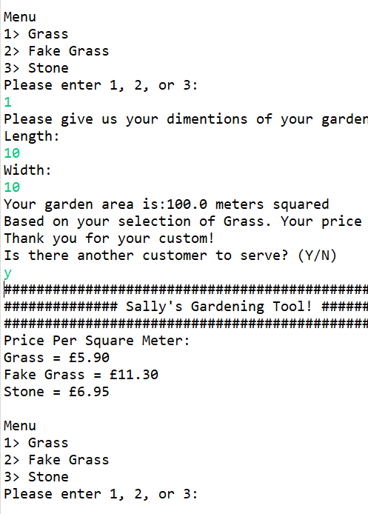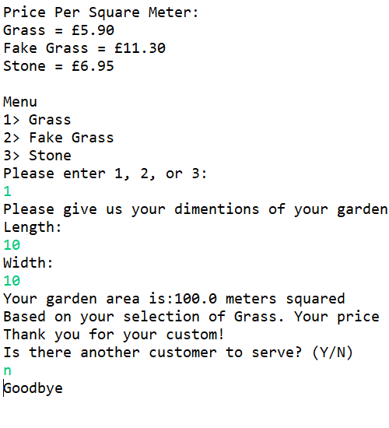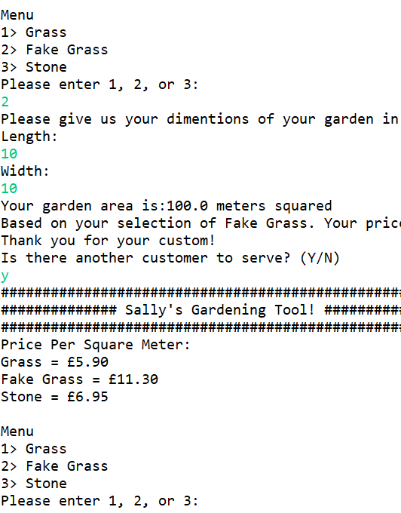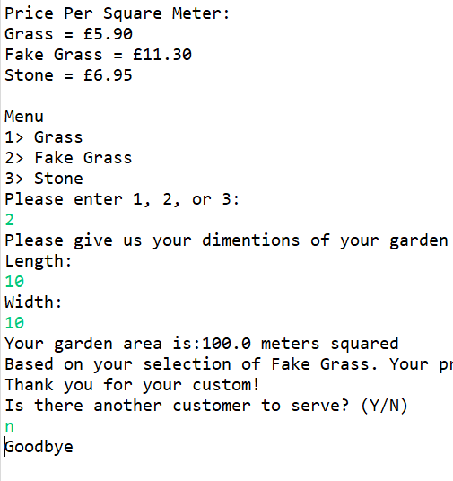

5. Option 3 LOOP 6. Option 3 EXIT

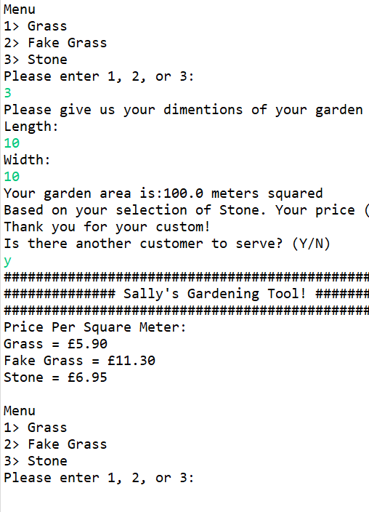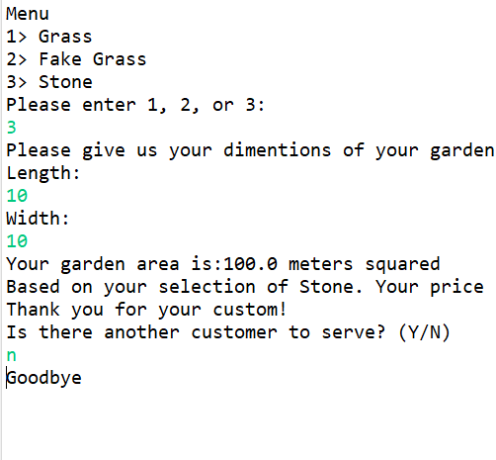

The next screenshots document upper range of length and width. I have picked test data of 1000 as it’s unlikely a small landscaping firm will sell 1 million meters squared of materials at any one time.

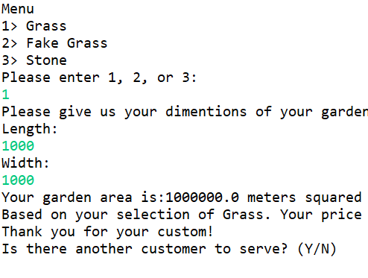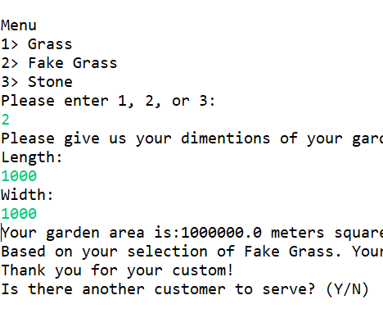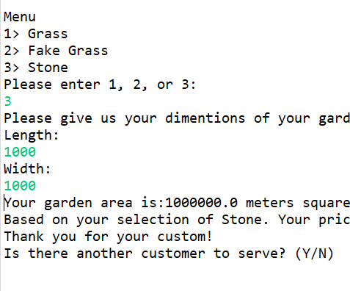

Flowchart

Implement solution

Logical Error

Syntax Errors?

Working as intended?

YES

NO

FOLLOW

**EVALUATION**

By using a half-step measure and drawing on previous programming experience I found it quick and easy to identify the issue, create a solution and implement a fix. By methodically testing I am confident that the program is working as the client intended.

Regarding the issue with a price being incorrect I would ask the client if they would like a feature where prices could be modified on their end to prevent this from happening and so they can adjust for inflation or adjust for a sale.

As the client did not specify this problem in the brief it has not been resolved but the code is subject to an InputMismatchException if an integer is not entered by the user. This could be easily fixed with exception handling. Again, this is something I would offer to incorporate into the code.

Next time I would add comments to the code, noting what has been changed, so if another programmer is brought in to look at it they can easily see how the code works and what has been changed.

**APPENDICES**

Figure 1 Initial Test Figure 2 Operator fix

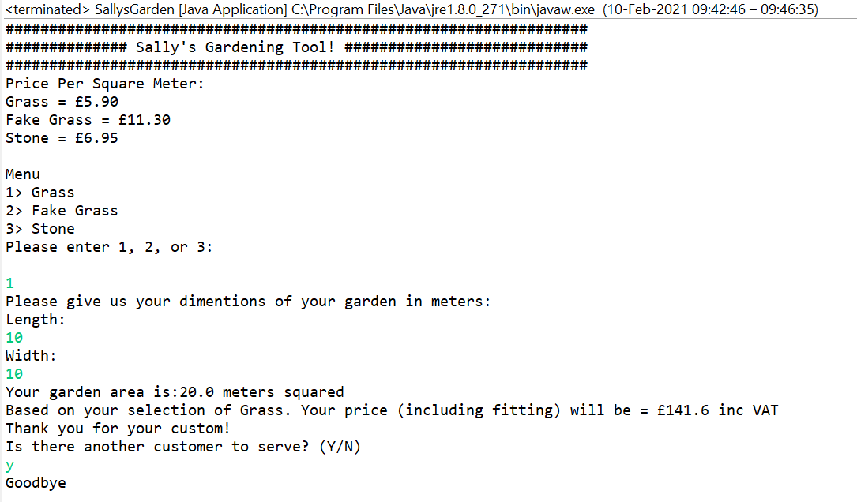 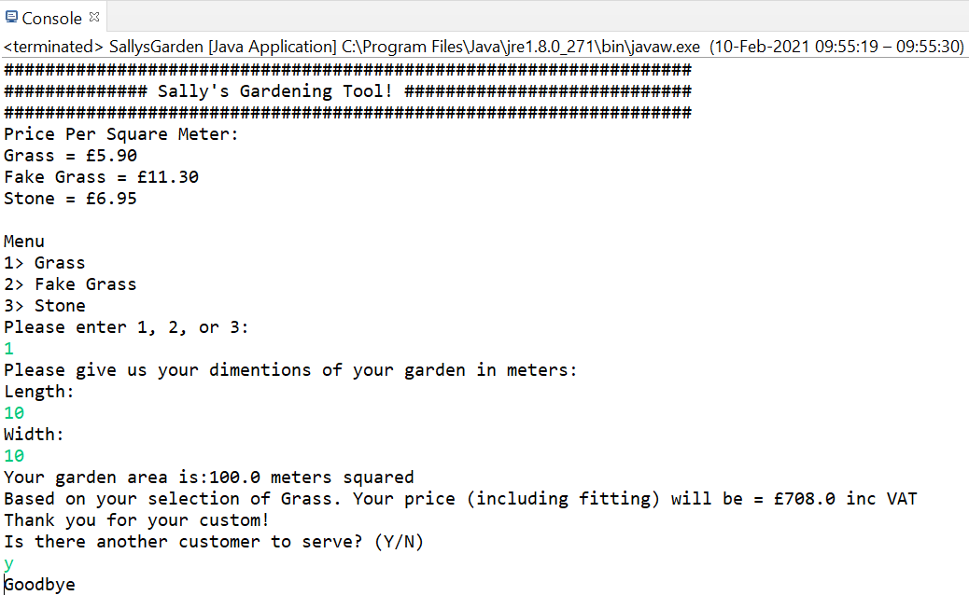

Figure 3 Calculation for fake grass Figure 4 case 2 price changed from 12.3 to 11.3

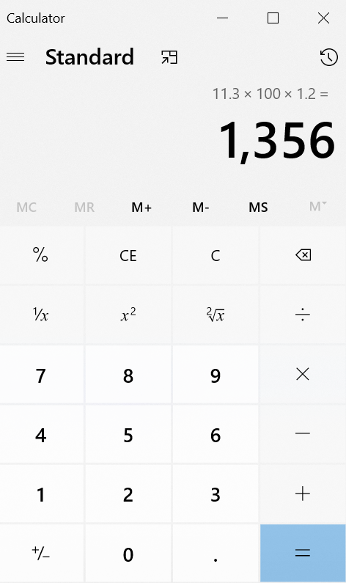 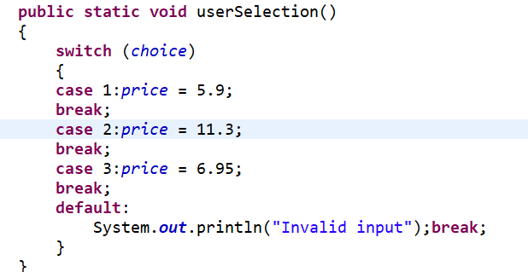

Figure 5 Program looping correctly Figure 6 Exiting correctly Figure 7 The modified loop

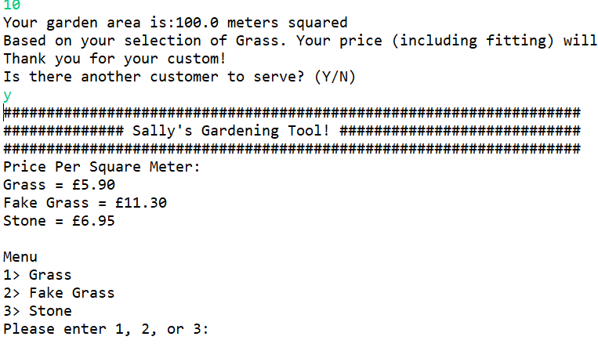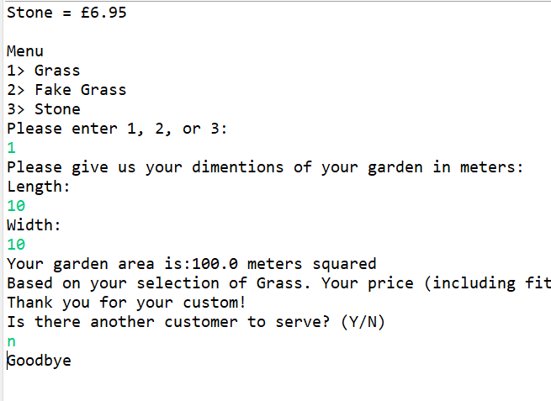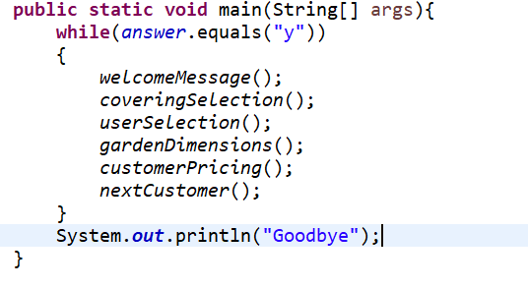

**CODE**

**import** java.util.Scanner;

**public** **class** SallysGarden

{

**public** **static** String *covering*;

**public** **static** String *answer* = "y";

**public** **static** **double** *price*, *gardenLength*, *gardenWidth*, *gardenArea*, *cost*;

**public** **static** Scanner *sc* = **new** Scanner(System.***in***);

**public** **static** **int** *choice*;

**public** **static** **void** main(String[] args){

**while**(*answer*.equals("y"))

{

*welcomeMessage*();

*coveringSelection*();

*userSelection*();

*gardenDimensions*();

*customerPricing*();

*nextCustomer*();

}

System.***out***.println("Goodbye");

}

**public** **static** **void** welcomeMessage()

{

System.***out***.println("###################################################################");System.***out***.println("############## Sally's Gardening Tool! ############################");System.***out***.println("###################################################################");

System.***out***.println("Price Per Square Meter:");

System.***out***.println("Grass = £5.90");

System.***out***.println("Fake Grass = £11.30");

System.***out***.println("Stone = £6.95");

System.***out***.println(" ");}

**public** **static** **void** coveringSelection()

{

System.***out***.println("Menu");

System.***out***.println("1> Grass");

System.***out***.println("2> Fake Grass");

System.***out***.println("3> Stone");

System.***out***.println("Please enter 1, 2, or 3: ");

*choice* = *sc*.nextInt();

}

**public** **static** **void** userSelection()

{

**switch** (*choice*)

{

**case** 1:*price* = 5.9;

**break**;

**case** 2:*price* = 11.3;

**break**;

**case** 3:*price* = 6.95;

**break**;

**default**:

System.***out***.println("Invalid input");**break**;

}

}

**public** **static** **void** gardenDimensions()

{

System.***out***.println("Please give us your dimentions of your garden in meters:");

System.***out***.println("Length: ");

*gardenLength* = *sc*.nextDouble();

System.***out***.println("Width: ");

*gardenWidth* = *sc*.nextDouble();

*gardenArea* = *gardenLength* * *gardenWidth*;

System.***out***.println("Your garden area is:" + *gardenArea* + " meters squared");

}

**public** **static** **void** customerPricing()

{

**if** (*choice* == 1) {*covering* = "Grass";

}

**else** **if**( *choice* == 2 )

{

*covering* = "Fake Grass";

}

**else** **if**(*choice* == 3)

{

*covering* = "Stone";

}

*cost* = (*gardenArea* * *price*) * 1.2;

System.***out***.println("Based on your selection of " + *covering* + ". Your price (including fitting) will be = £" + *cost* + " inc VAT");

System.***out***.println("Thank you for your custom!");

}

**public** **static** **void** nextCustomer()

{

System.***out***.println("Is there another customer to serve? (Y/N)");

*answer* = *sc*.next().toLowerCase();

}

}